HOW TO CHANGE THE ILO PASSWORD OF THE HP PHYSICAL MACHINES

rpm -qa |grep -i hponcfg
hponcfg-1.9.0-3.noarch

Check the content of the package.

# rpm -ql hponcfg-1.9.0-3
/sbin/hponcfg

Execute below commands

hponcfg -w /tmp/ilosamplefile.out

less /tmp/ilosamplefile.out

You will see output something like below, note down the RIBCL VERSION

<RIBCL VERSION="2.0">
<LOGIN USER_LOGIN="Administrator" PASSWORD="password">
<DIR_INFO MODE="write">
<MOD_DIR_CONFIG>
<DIR_AUTHENTICATION_ENABLED VALUE = "N"/>
<DIR_LOCAL_USER_ACCT VALUE = "Y"/>
<DIR_SERVER_ADDRESS VALUE = ""/>
<DIR_SERVER_PORT VALUE = "636"/>
<DIR_OBJECT_DN VALUE = ""/>
<DIR_OBJECT_PASSWORD VALUE = ""/>
<DIR_USER_CONTEXT_1 VALUE = ""/>
<DIR_USER_CONTEXT_2 VALUE = ""/>
<DIR_USER_CONTEXT_3 VALUE = ""/>
</MOD_DIR_CONFIG>
</DIR_INFO>
<RIB_INFO MODE="write">
<MOD_NETWORK_SETTINGS>

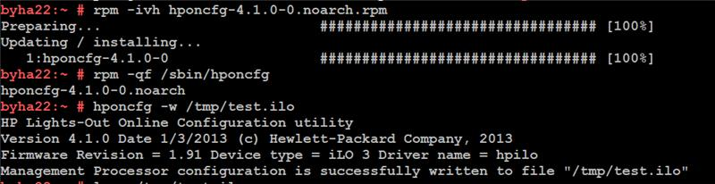

Add the content in the file ( do not perform any syntax error ) for e.g vi passwd_reset_ilo.xml

<RIBCL VERSION="2.0">
<LOGIN USER_LOGIN="x" PASSWORD="x">
<USER_INFO MODE="write">
<MOD_USER USER_LOGIN="Administrator">
<PASSWORD value="pa$$word"/>
</MOD_USER>
</USER_INFO>
</LOGIN>
</RIBCL>

Ensure that RIBCL VERSION should be same as mentioned in the ilosamplefile.out

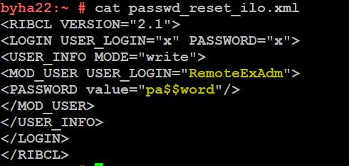

Run the below command to reset the Administrator password.

# hponcfg -f passwd_reset_ilo.xml -l log.txt
Firmware Revision = 1.92 Device type = iLO Driver name = hpilo
Script succeeded

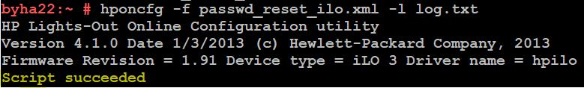

Once the Script is succeeded use login id as Administrator and password as pa$$word in ILO Console

However if you would like to change the password for USER say for example “CG_Admin or Something similar which is also having ADMIN_PRIV value = “Y”/ in the ilosamplefile.out then you can also do the repeat the process just like for user “Administrator” but ensure the RIBCL VERSION should be same as mentioned in hponcfg -w /tmp/ilosamplefile.out output.

